**Understanding The Basics of SVM With Example and Python Implementation**

When you enter the Machine Learning dimension, it is highly likely that one of the first classifier algorithms you might come across is SVM, you will find that SVM is all over the place. SVM which stands for Support Vector Machine is one of the most popular classification algorithms used in Machine Learning.

In this article, we will learn about the intuition behind SVM classifier, how it classifies and also to implement an SVM classifier in python.

### **What is SVM?**

**Support Vector Machine** or SVM is a supervised and linear Machine Learning algorithm most commonly used for solving classification problems and is also referred to as **Support Vector Classification**. There is also a subset of SVM called SVR which stands for **Support Vector Regression** which uses the same principles to solve regression problems. SVM also supports the kernel method also called the **kernel SVM**which allows us to tackle non-linearity.

### **How SVM works?**

Just for the sake of understanding, we will leave the machines out of the picture for a minute. Now how would a human being like you and me classify a set of objects scattered on the surface of a table? Of course, we will consider all their physical and visual characteristics and then identify based on our prior knowledge. We can easily identify and distinguish apples and oranges based on their color, texture, shape etc.

Now bringing back the machines, how would a machine identify an apple or an orange. Not surprisingly, it is based on the characteristics that we provide the machine with. It can be size, shape, weight etc. The more features we consider the easier it is to identify and distinguish both.

For the time being, we will just focus on the weight and size(diameter) of apples and oranges. Now how would a machine using SVM, classify a new fruit as either apple or orange just based on the data on the size and weights of some 20 apples and oranges that were observed and labelled? The below image depicts how.

[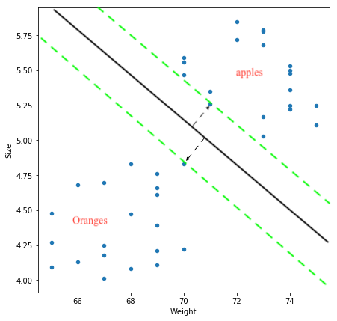](https://www.analyticsindiamag.com/wp-content/uploads/2019/06/applesvsoranges.png)

The objective of SVM is to draw a line that best separates the two classes of data points.

SVM generates a line that can cleanly separate the two classes. How clean, you may ask. There are many possible ways of drawing a line that separates the two classes, however, in SVM, it is determined by the **margins** and the**support vectors**.

The margin is the area separating the two dotted green lines as shown in the image above. The more the margin the better the classes are separated. The support vectors are the data points through which each of the green lines passes through. These points are called support vectors as they contribute to the margins and hence the classifier itself. These support vectors are simply the data points lying closest to the border of either of the classes which has a probability of being in either one.

The SVM then generates a hyperplane which has the maximum margin, in this case the black bold line that separates the two classes which is at an optimum distance between both the classes.

In case of more than 2 features and multiple dimensions, the line is replaced by a hyperplane that separates multidimensional spaces.

### **Implementing SVM in Python**

Now that we have understood the basics of SVM, let’s try to implement it in Python. Just like the intuition that we saw above the implementation is very simple and straightforward with Scikit Learn’s svm package.

Let’s use the same dataset of apples and oranges. We will consider the Weights and Size for 20 each.

**Importing the dataset**

import pandas as pd  
data = pd.read_csv("apples_and_oranges.csv")

Here is what it looks like:

[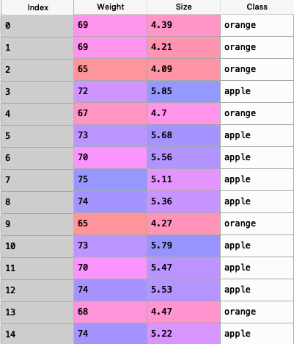](https://www.analyticsindiamag.com/wp-content/uploads/2019/06/data_applesvsoranges.png)

**Splitting the dataset into training and test samples**

from sklearn.model_selection import train_test_split  
training_set, test_set = train_test_split(data, test_size = 0.2, random_state = 1)

**Classifying the predictors and target**

X_train = training_set.iloc[:,0:2].values  
Y_train = training_set.iloc[:,2].values  
X_test = test_set.iloc[:,0:2].values  
Y_test = test_set.iloc[:,2].values

**Initializing Support Vector Machine and fitting the training data**

from sklearn.svm import SVC  
classifier = SVC(kernel='rbf', random_state = 1)  
classifier.fit(X_train,Y_train)

**Predicting the classes for test set**

Y_pred = classifier.predict(X_test)

**Attaching the predictions to test set for comparing**

test_set["Predictions"] = Y_pred

**Comparing the actual classes and predictions**

Let’s have a look at the test_set:

[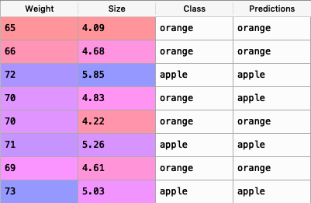](https://www.analyticsindiamag.com/wp-content/uploads/2019/06/actual_vs_predictions.png)

Comparing the ‘Class’ and ‘Predictions’ column we find that only one of the 8 predictions has gone wrong.

**Calculating the accuracy of the predictions**

We will calculate the accuracy using the confusion matrix as follows :

from sklearn.metrics import confusion_matrix  
cm = confusion_matrix(Y_test,Y_pred)  
accuracy = float(cm.diagonal().sum())/len(Y_test)  
print("\nAccuracy Of SVM For The Given Dataset : ", accuracy)

Output:

Accuracy Of SVM For The Given Dataset :  1.0

**Visualizing the classifier**

Before we visualize we might need to encode the classes ‘apple’ and ‘orange’ into numericals. We can achieve that using the label encoder.

from sklearn.preprocessing import LabelEncoder  
le = LabelEncoder()  
Y_train = le.fit_transform(Y_train)

After encoding , fit the encoded data to the SVM

from sklearn.svm import SVC  
classifier = SVC(kernel='rbf', random_state = 1)  
classifier.fit(X_train,Y_train)

Let’s Visualize!

import numpy as np  
import matplotlib.pyplot as plt  
from matplotlib.colors import ListedColormap  
plt.figure(figsize = (7,7))  
X_set, y_set = X_train, Y_train  
X1, X2 = np.meshgrid(np.arange(start = X_set[:, 0].min() - 1, stop = X_set[:, 0].max() + 1, step = 0.01), np.arange(start = X_set[:, 1].min() - 1, stop = X_set[:, 1].max() + 1, step = 0.01))  
plt.contourf(X1, X2, classifier.predict(np.array([X1.ravel(), X2.ravel()]).T).reshape(X1.shape), alpha = 0.75, cmap = ListedColormap(('black', 'white')))  
plt.xlim(X1.min(), X1.max())  
plt.ylim(X2.min(), X2.max())  
for i, j in enumerate(np.unique(y_set)):  
plt.scatter(X_set[y_set == j, 0], X_set[y_set == j, 1], c = ListedColormap(('red', 'orange'))(i), label = j)  
plt.title('Apples Vs Oranges')  
plt.xlabel('Weight In Grams')  
plt.ylabel('Size in cm')  
plt.legend()  
plt.show()

Output :

[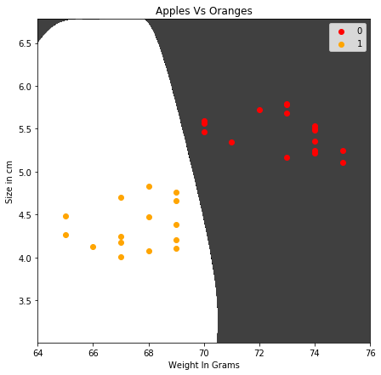](https://www.analyticsindiamag.com/wp-content/uploads/2019/06/apples_oranges_svm1.png)

The above image shows the plotting of the training set after fitting the training data to the classifier.The border that separates both the white and black colours represent the Maximum Margin Hyperplane or Line in this case.

According to the SVM classifier, any new data point that falls within the white region is classified as oranges(denoted in orange colour) and any data point that falls on black region is classified as apples(denoted in red colour).

**Visualizing the predictions**

import numpy as np  
import matplotlib.pyplot as plt  
from matplotlib.colors import ListedColormap  
plt.figure(figsize = (7,7))  
X_set, y_set = X_test, Y_test  
X1, X2 = np.meshgrid(np.arange(start = X_set[:, 0].min() - 1, stop = X_set[:, 0].max() + 1, step = 0.01),np.arange(start = X_set[:, 1].min() - 1, stop = X_set[:, 1].max() + 1, step = 0.01))  
plt.contourf(X1, X2, classifier.predict(np.array([X1.ravel(), X2.ravel()]).T).reshape(X1.shape),alpha = 0.75, cmap = ListedColormap(('black', 'white')))  
plt.xlim(X1.min(), X1.max())  
plt.ylim(X2.min(), X2.max())  
for i, j in enumerate(np.unique(y_set)):  
plt.scatter(X_set[y_set == j, 0], X_set[y_set == j, 1],c = ListedColormap(('red', 'orange'))(i), label = j)  
plt.title('Apples Vs Oranges Predictions')  
plt.xlabel('Weight In Grams')  
plt.ylabel('Size in cm')  
plt.legend()  
plt.show()

Output:

[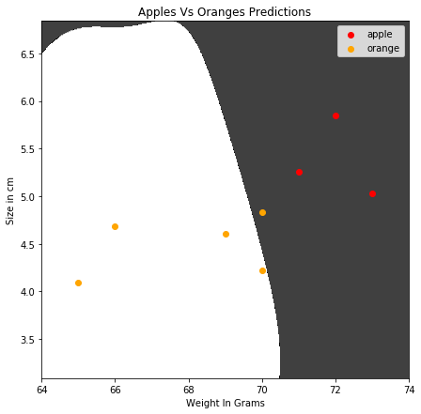](https://www.analyticsindiamag.com/wp-content/uploads/2019/06/apples_oranges_svm_predictions.png)